A156-ME-Bactria-Margiana-seated female figure-14 cm

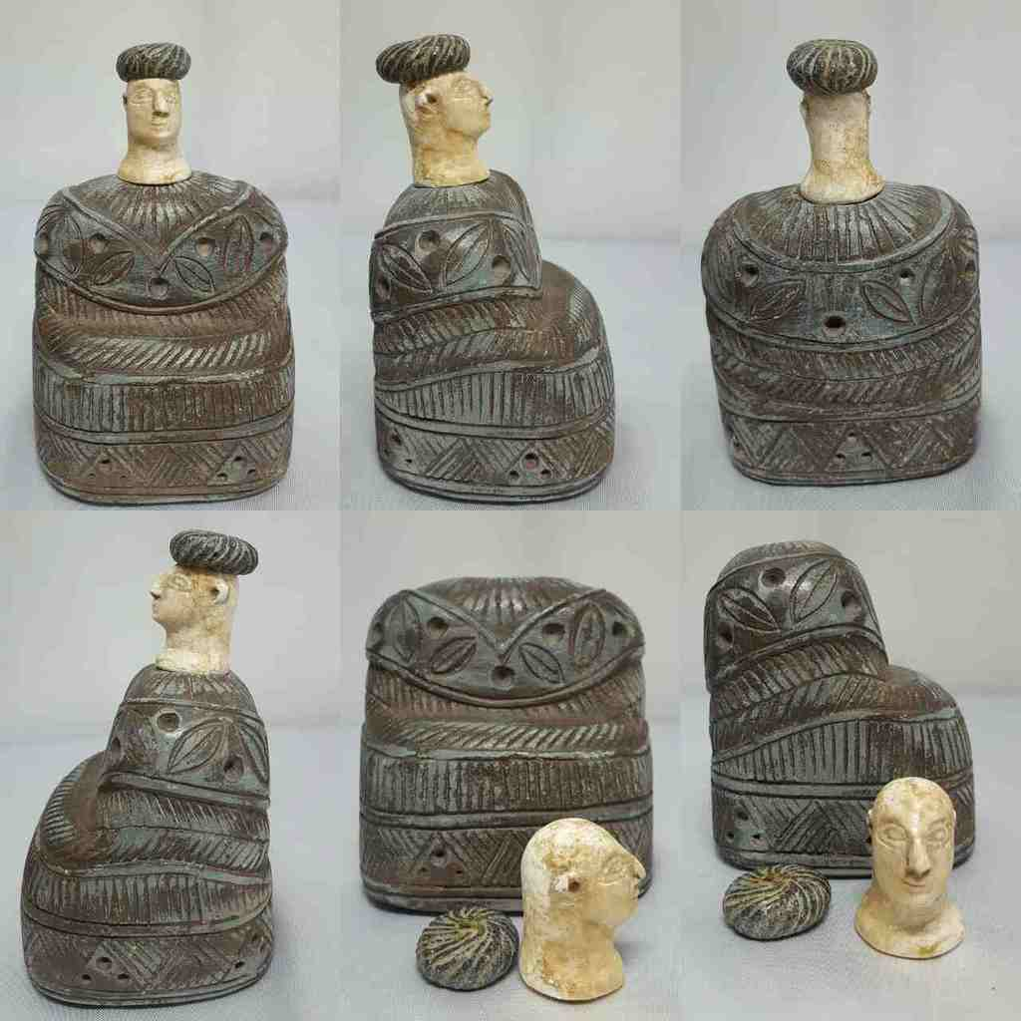

**Formal Label:** Bactria-Margiana composite chlorite and white calcite seated female with chlorite cap, Middle to Late Bronze Age, 2000-1650 BCE

**Accession Number:** GN778.32.A4

Display Description:

The carved chlorite body depicts a caunakes (woolen skirt), the head is made of calcite, the cap is carved from black bitumen. This statue is from the Margiana culture c 2000-1650 BCE, and cylinder seals of the period show similar women's figures. This figure may be a goddess of fertility, a symbol of the life force of revitalization, or it may be a revered ancestor.

**Date or Time Horizon:** Middle to Late Bronze Age, 2000-1650 BCE

**Geographical Area:** Afghanistan

Map:

This Bactria­ Margiana Archaeological Complex, a Bronze Age civilization of Central Asia-2300-1700 BCE in n Afghanistan, e Turkmenistan, s Uzbekistan and w Tajikistan is focused on the upper Oxus River (Amu Darya) that flows nw into the Aral Sea.



Fig. 1. Map of BMAC area in the upper Oxus River (Amu Darya) watershed that drains Afghanistan, Uzbekistan, Turkmenistan, and Tajikistan into the Aral Sea. Modified after a map created by Shannon1 4 February 2010 using [DEMIS Mapserver](http://www2.demis.nl/mapserver/mapper.asp).



Fig. 2. BMAC sites: *Margiana* the Greek name for the Persian province of [Margiana](https://en.wikipedia.org/wiki/Margiana) (Mouru/Margu/Marv) with its capital, [Merv](https://en.wikipedia.org/wiki/Merv) (Bayramali) in se Turkmenistan. Murgab delta and oasis (circled) in the south of Turkmenistan. The Murgab river spreads out and disappears into the Kara Kum desert to the north

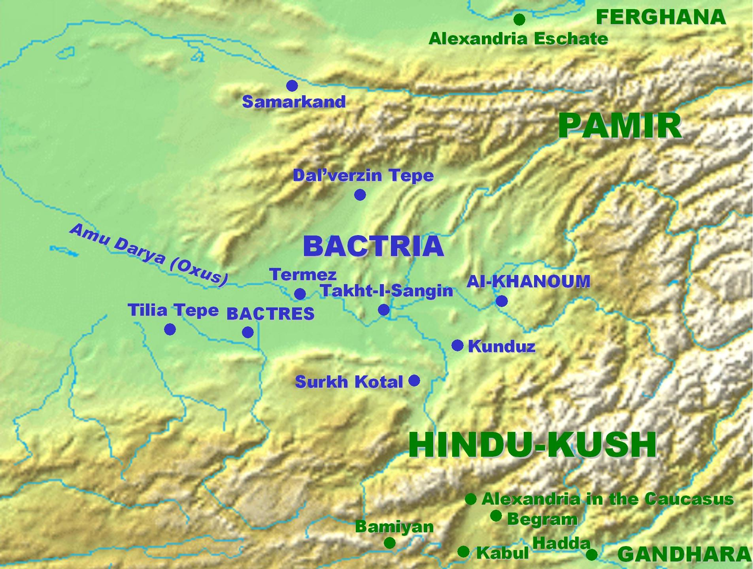

Fig. 3. BMAC sites: Bactria the Greek name for Balkh in n Afghanistan.

GPS:

**Cultural Affiliation:** BMAC (Oxus)

**Media:** composite chlorite body and cap and white calcite head

**Dimensions:** H 14 cm x W 10 cm

**Weight:**

**Provenance:** [**vintage.intaglio**](http://myworld.ebay.com/vintage.intaglio), Thailand

**Discussion:**

This type of statuette, which can be separated into green chlorite for the base and hat and white chlorite for the head, originated with the Oxus civilization now known as the Bartria-Margiana Archaeological Complex (BMAC), which occupies in Central Asia the territories of Bactria, to the east, and Margiana, to the west.

The biggest volume of the room is occupied by a very large caunakes (woolen skirt), with puffed sleeves, covered from the waist by a gown which accentuates its amplitude; The two parts of the garment are of a woolly material stylized in superposed tabs, which is obviously inspired by the Sumerian kaunakes, skirt with long hair arranged in scales. A rigid headgear with a tip at the back encloses all the hair and makes it difficult to distinguish between the two.

The manufacture obeys very precise canons: head and costume are carved in a gray steatite, while the lightest stone serves uncovered parts of the body; The module corresponding to the face and neck extended by a décolleté begins to fit exactly into the neckline of the garment. The arms and hands, now lost, were lodged in the mortises at the end of the sleeves and resting on the small platform formed at the front at the waist.

The "princesses of Bactria" eventually represented ladies of the aristocracy, perhaps even deified, but most often they personified the first-rate goddess who in the mythology of Central Asia plays a regulatory role in the order of nature, pacifying the wild forces incarnated by lions, serpents or dragons. It is very identifiable in the glyptic, its identity is more controversial in the statuary.

